**Linear Regression** is a machine learning algorithm based on supervised learning. It performs a regression task. Regression models a target prediction value based on independent variables. It is mostly used for finding out the relationship between variables and forecasting. Different regression models differ based on – the kind of relationship between dependent and independent variables they are considering, and the number of independent variables getting used. There are many names for a regression’s dependent variable. It may be called an outcome variable, criterion variable, endogenous variable, or regressand. The independent variables can be called exogenous variables, predictor variables, or regressors.

Types of Linear Regression

Linear regression can be further divided into two types of the algorithm:

* **Simple Linear Regression:**  
  If a single independent variable is used to predict the value of a numerical dependent variable, then such a Linear Regression algorithm is called Simple Linear Regression.
* **Multiple Linear regression:**  
  If more than one independent variable is used to predict the value of a numerical dependent variable, then such a Linear Regression algorithm is called Multiple Linear Regression.

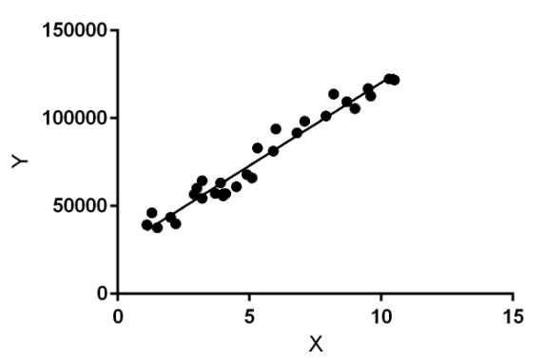

**Random Forest** is a popular machine learning algorithm that belongs to the supervised learning technique. It can be used for both Classification and Regression problems in ML. It is based on the concept of **ensemble learning,** which is a process of combining multiple classifiers to solve a complex problem and to improve the performance of the model.

Below are some points that explain why we should use the Random Forest algorithm:

<="" li="">

* It takes less training time as compared to other algorithms.
* It predicts output with high accuracy, even for the large dataset it runs efficiently.
* It can also maintain accuracy when a large proportion of data is missing

Advantages of Random Forest

* Random Forest is capable of performing both Classification and Regression tasks.
* It is capable of handling large datasets with high dimensionality.
* It enhances the accuracy of the model and prevents the overfitting issue.

Disadvantages of Random Forest

* Although random forest can be used for both classification and regression tasks, it is not more suitable for Regression tasks.

